190228 CS E

# Task 1

#include<iostream>

using namespace std;

int* Resize(int *arr_a , int &size)

{

size++;

int *arr_b = new int[size];

cout << " Enter Array Index " << size << " = ";

cin >> arr_b[size-1];

for (int i = 0; i < size-1; i++)

arr_b[i]=arr_a[i];

return arr_b;

}

int main()

{

int Size, *arr,ch=0;

cout << " Enter Size of Array : "; cin >> Size;

arr = new int[Size];

for (int i = 0; true; i++)

{

if (i < Size)

{

cout << " Enter Array Index " << i << " = ";

cin >> arr[i];

}

else

{

cout << " You Exceeds the Size of Array " << endl;

arr = Resize(arr, i);

Size = i;

cout << "Press 1- For Exit or Continue for Press any other Key : "; cin >> ch;

if (ch == 1)

break;

else

i--;

}

}

cout << " Array Is : ";

for (int i = 0; i < Size; i++)

cout << arr[i] << " ";

}

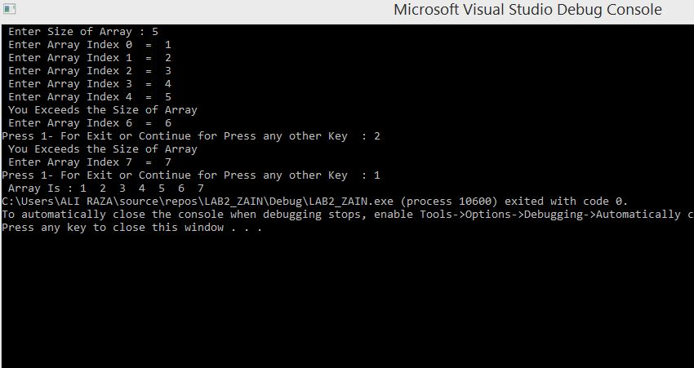

# TASK 2

#include<iostream>

#include<string.h>

using namespace std;

// ENCODED FUNCTION

void GenrateCode(int* p1, int* p2, char* line)

{

for (int i = 0; i < 30; i++)

{

if (*(line + i) >= 65 && *(line + i) <= 90)//ascii set

{

if (*(line + i) + *p1 >= 65 && *(line + i) + *p1 <= 90)

*(line + i) += *p1;

else

*(line + i) += *p1 - 26;

}

else

{

if (*(line + i) >= 97 && *(line + i) <= 122)

{

if (*(line + i) + *p2 >= 97 && *(line + i) + *p2 <= 122)

*(line + i) += *p2;

else

*(line + i) += *p2 - 26;

}

}

}

}

// DECODED FUNCTION

void DeCode(int* p1, int* p2, char* line)

{

for (int i = 0; i < 30; i++)

{

if (*(line + i) >= 65 && *(line + i) <= 90)

{

if (*(line + i) - *p1 >= 65 && *(line + i) - *p1 <= 90)

*(line + i) -= *p1;

else

*(line + i) -= *p1 - 26;

}

else

{

if (*(line + i) >= 97 && *(line + i) <= 122)

{

if (*(line + i) - *p2 >= 97 && *(line + i) - *p2 <= 122)

*(line + i) -= *p2;

else

*(line + i) -= *p2 - 26;

}

}

}

}

// MAIN FUNCTION

int main()

{

int a = 0, b = 0, rollno, count = 0;

char input[30];

int* ptr1, * ptr2;

cout << " Enter Your CodeWord Or RollNo : ";

cin >> rollno;

while (count <= 3)

{

if (count <= 1)

{

b += rollno % 10;

rollno = rollno / 10;

}

else

{

a += rollno % 10;

rollno = rollno / 10;

}

count++;

}

a = a + 1; b = b + 1; ptr1 = &a; ptr2 = &b;

cout << " Enter Input ( Text ): ";

cin >> input;

GenrateCode(ptr1, ptr2, input);

cout << endl << " EnCoded Data : " << input << endl;

cout << " Press Any Key For DeCode Data " << endl;

system("pause");

DeCode(ptr1, ptr2, input);

cout << " DeCoded Data : " << input << endl;

}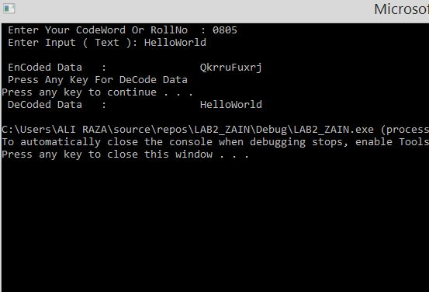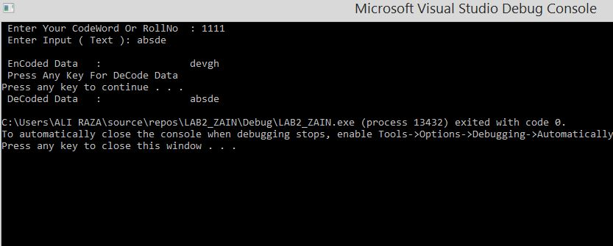

# TASK 3

// CONVERT STRING INTO 2D ARRAY

#include<iostream>

#include<string>

using namespace std;

int main()

{

char** ptr;//double pointer

int size=0;

string name;

cout << "Enter any string : ";

getline(cin, name);//getline for inclusion of space

for (int i = 0; name[i] != '\0'; i++)//this loop only increases the size

{

size++;

}

ptr = new char* [size];

for (int i = 0; i < size; i++)

{

ptr[i] = new char[size];

}

int k = 0;

for (int i = 0; i<=size; i++)

{

int j = 0;

if (name[i] == 32)

{

cout << endl; k++;

}

else

{

ptr[k][j] = name[i];

cout << ptr[k][j];

;

j++;

}

}

